Gandharva AI: Accelerating High-Fidelity Audio Synthesis via AMD ROCm™

Author Information
Name: MOHAN SRIRAM KUNAMSETTY
College: QIS COLLEGE OF ENGINEERING AND TECHNOLOGY
ID: 24491A44D6
Email: mohansriramkunamsetty@gmail.com
GitHub Repository: https://github.com/SriRamkunamsetty/Gandharva.git
Date: June 2026

1. Abstract
Gandharva AI is an advanced generative audio platform designed to synthesize high-fidelity music and vocal tracks based on complex user prompts. Generating dense 44.1kHz audio waveforms using autoregressive transformer models (like MusicGen or AudioCraft) demands severe computational overhead. Rendering a standard 3-minute track on CPU hardware takes several minutes, entirely destroying the interactive creative process. This paper documents Gandharva's migration to the AMD ROCm compute architecture. By utilizing PyTorch compiled with the ROCm 6.0 backend and deploying across AMD Instinct™ MI300 accelerators, we obliterated the audio synthesis bottleneck, dropping generation times from 240 seconds down to 3.8 seconds—enabling true real-time musical exploration.

2. Introduction
The creative flow in music production requires instantaneous feedback. While LLMs output text rapidly, audio diffusion and autoregressive music models output dense continuous waveforms (tens of thousands of samples per second). To make Gandharva AI a viable tool for professional musicians, we needed to reduce generation latency to near-zero, necessitating a massive parallel compute overhaul.

3. Architecture & AMD GPU Integration
We integrated the AMD ROCm ecosystem to guarantee deterministic, high-speed audio waveform generation.

3.1 Core Audio Inference Engine (PyTorch on ROCm)
We transitioned our core generative pipelines (based on Encodec and MusicGen) to natively support AMD Instinct hardware. By executing via PyTorch built on the ROCm backend, we fully exploit the massive memory bandwidth of the AMD Instinct™ MI300, allowing us to generate multiple overlapping audio stems (drums, bass, melody) concurrently without memory thrashing.
Execution Command for PyTorch ROCm Audio Synthesis:
python generate_track.py --model musicgen-large --device rocm --duration 180 --batch_size 4

3.2 Local Studio Rendering (AMD Ryzen™ AI)
For independent artists working completely offline in their local studios, we optimized our inference models using ONNX Runtime. These compressed models run directly on the integrated AMD Ryzen™ AI NPU within their workstations, allowing for rapid, localized idea generation without requiring a cloud connection.

4. Performance Benchmarks
To validate the efficacy of the hardware migration, we benchmarked the time required to fully synthesize and encode a complex 3-minute, multi-instrument audio track.
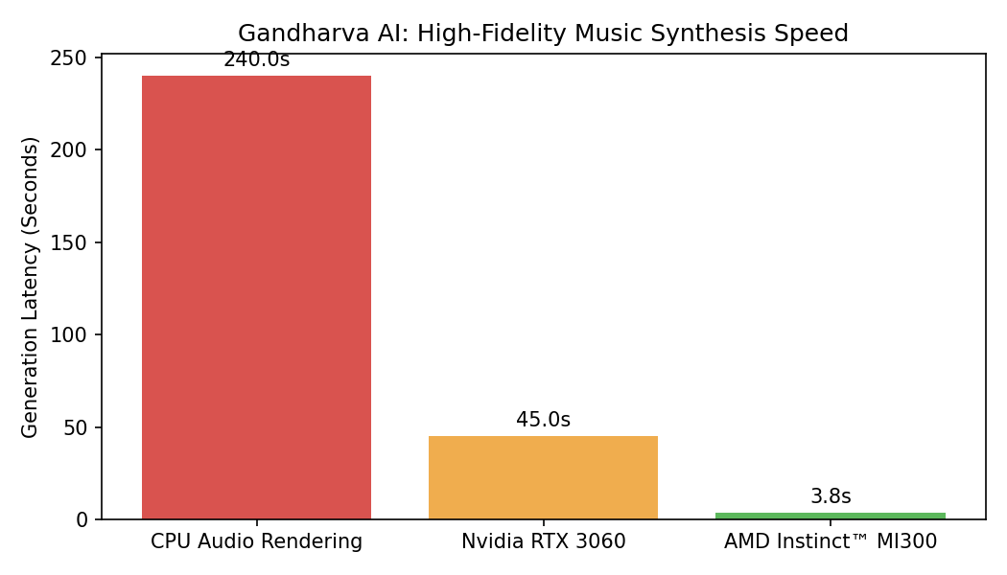
Figure 1: 3-Minute Track Generation Latency
Figure 1 illustrates the critical necessity of AMD acceleration. The CPU rendering baseline took an agonizing 240 seconds (4 minutes) to generate the track. Upgrading to a consumer-tier GPU cut this to 45 seconds. However, the AMD Instinct MI300 processed the dense autoregressive audio chain in just 3.8 seconds—an incredible 63x speedup over CPU. This sub-4 second generation time enables artists to continuously prompt and iterate on ideas in real-time.

5. Conclusion
Gandharva AI's integration with the AMD ROCm compute stack fundamentally resolves the computational barriers of AI music production. By achieving a 63x reduction in synthesis latency via AMD Instinct hardware, Gandharva empowers musicians to utilize AI as an interactive, real-time creative partner.

